**A**

***PROJECT REPORT***

*On*

“JOBNET WEBSITE”

***In partial fulfilment for the award of the degree of***

## BACHELOR OF TECHNOLOGY

## Techno_1_.Logo

**Submitted by**

**Aryan Jain**

**(18ETCCS011)**

**Avi Kumar Tripathi**

**(18ETCCS014)**

**Divyadarshan choubisa**

**(19etccs201)**

**Department Of Computer Science Engineering**

**TECHNO INDIA NJR INSTITUTE OF TECHNOLOGY, UDAIPUR**

**2018-2022**

# Acknowledgements

Many people have supported me, in different ways, during the work with the thesis. I’d like to thank my guide Mr Aditiya Maheshwari for their kind and active support and valuable guidance during the work process. My family has as always offered me their unconditional support, thank you! I have taken efforts in the Project. However, it would not have been possible without the kind support and many individuals and organizations. I would like to extend my sincere thanks to each and every members related to Techno India NJR institute Of Technology

Aryan Jain

Avi Tripathi

Divyadarshan choubisa

### TECHNO INDIA NJR INSTITUTE OF TECHNOLOGY

## CERTIFICATE

This is to certify that this project report **JOBNET WEBSITE”** is the confide work of **“ARYAN JAIN , AVI KUMAR TRIPATHI , DIVYADARSHAN CHOBISA ”** who have carried out the project work under my supervision. I approve this project for submission of the Bachelor of Technology in the **Department of Computer Science and Engineering, Techno India NJR Institute of Technology**, affiliated to Rajasthan Technical University, Kota.

MR. ADITIYA MAHESHWARI

Department of Computer Science

## PREFACE

The well planned, properly executed and evaluated curriculum of Btech 4th year helps a lot in inoculating the theory in practical work. It provides linkage between the student and the industry in order to develop the awareness and knowledge of the industrial approach & to develop problem-solving skills based on broad understanding of plant, process, product, and mode of operations of an industrial organization.

The project entitled “JOBNET” facilitates to advance the university’s mission, brand and message(s) to core constituents i.e. its prospective students, parents, the media and the casual visitors. This will be done in a manner that is:

1. Dynamic and user-friendly, and can readily adapt to meet the diverse and changing needs of its constituents.
2. Provides targeted and user-friendly interaction e.g. prospective student inquiries, requests for information, online applications etc.
3. Developing a website which is device independent.

A secondary purpose of this project is to provide information to the campus community i.e. faculty, staff, students, and parents while keeping in mind that all the content is relevant, fresh, engaging and easily navigable.

This project has been developed using XAMPP at Techno India NJR Institute of technology. This project is user-friendly, easy to use, and understandable and satisfies all requirements for an institution.

## TABLE OF CONTENTS

|  |  |  |
| --- | --- | --- |
| **S. No.** | **Headings** | **Page No.** |
| **1.** | **CHAPTER 1 : Introduction** | 1-2 |
| **1.1.** | Introduction | 1 |
| **1.2.** | Technical specifications | 1-2 |
| **2.** | **CHAPTER 2 : Technologies used** | 3-7 |
| **2.1.** | Front and Back End tools | 3 |
| **2.2.** | Front End Technologies: | 3-6 |
| **2.2.1.** | HYPERTEXT MARKUP LANGUAGE (HTML) | 3 |
| **2.2.2.** | HYPERTEXT PRE PROCESSOR (PHP) | 4 |
| **2.2.3.** | JQuery | 4 |
| **2.2.4.** | JAVASCRIPT | 5 |
| **2.2.5.** | CASCADING STYLE SHEET (CSS) | 6 |
| **2.2.6.** | BOOTSTRAP | 6 |
| **2.3.** | Back End Technology: | 7 |
| **2.3.1.** | MySQL SERVER | 7 |
| **3.** | **CHAPTER 3 : System Analysis & System Study** | 8-10 |
| **3.1.** | Project Analysis | 8 |
| **3.2.** | Feasibility Study: | 9-10 |
| **3.2.1.** | Technical Feasibility | 9 |
| **3.2.2.** | Economic Feasibility | 9 |
| **3.2.3.** | Operational Feasibility | 10 |
| **3.3.** | Cost & Benefit Analysis | 10 |
| **4.** | **CHAPTER 4 : Project Design** | 11-45 |
| **4.1.** | Data Dictionary | 11-13 |
| **4.2.** | Data Flow Diagram (DFD): | 14-16 |
| **4.2.1.** | Zero level DFD | 14 |
| **4.2.2.** | Level one DFD for 1.0 | 15 |

|  |  |  |
| --- | --- | --- |
| **S. No.** | **Heads** | **Page No.** |
| **4.2.3.** | Level one DFD for 2.0 | 15 |
| **4.2.4.** | Level one DFD for 3.0 | 16 |
| **4.3.** | Entity Relationship Diagram (ERD) | 17 |
| **4.4.** | Database structures | 18-21 |
| **4.5.** | Snap Shots of designing phase | 22-45 |
| **5.** | **CHAPTER 5 : Mechanisms used** | 46-47 |
| **5.1.** | Testing overview: | 46 |
| **5.1.1.** | System testing | 47 |
| **6.** | **CHAPTER 6 : Implementation** | 48-49 |
| **6.1.** | Implementation mechanisms used | 48-49 |
| **7.** | **CHAPTER 7 : Limitation** | 50 |
| **7.1.** | Limitations | 50 |
| **8.** | **CHAPTER 8 : Conclusion** | 51 |
| **8.1.** | Conclusion | 51 |
| **9.** | **CHAPTER 9 : Future scope** | 52 |
| **9.1.** | Future scope | 52 |

**REFERENCES**

* + [www.php.net](http://www.php.net/)
  + [www.sitepoint.com](http://www.sitepoint.com/)
  + [www.superuser.com](http://www.superuser.com/)
  + [www.fontawesome.com](http://www.fontawesome.com/)
  + [www.fonts.google.com](http://www.fonts.google.com/)
  + [www.instant-eyedropper.com](http://www.instant-eyedropper.com/)
  + [www.stackoverflow.com](http://www.stackoverflow.com/)
  + [www.codyhouse.co](http://www.codyhouse.co/)
  + [www.w3schools.com](http://www.w3schools.com/)
  + [www.javatpoint.com](http://www.javatpoint.com/)
  + [www.mysql.co](http://www.mysql.com/)m

## CHAPTER 1 INTRODUCTION

### Introduction:

The job industry is facing a lot of competition along with the growth of society and the need for qualified manpower. Unlike the old days, today there are many options for the same and with the advent of internet this process has become easier and user-friendly. The search for the right job sometimes makes the seekers run here & there and this is where the Placement consultants come in, by acting as a platform between them and the premier hiring companies. A Placement Consultancy or a Recruitment firm acts as a link between the companies that offer jobs in various areas and the [job-](https://www.placementindia.com/job-search/) [seekers.](https://www.placementindia.com/job-search/) They also help reduce the clutter and streamline the manpower hunting for the companies no matter how big or small. They act as a guide to the job-seeker to guide them with their career prospects. Many companies hire these [recruitment firms or agencies](https://www.placementindia.com/recruitment-agency/) to help them find the right qualified candidate to join their company. Job seekers in turn, contact these recruitment firms to apply for the right job.

### Technical specifications:

Specifications of the System used to develop and test the website-: Software Requirements-

* + - Operating Systems : Windows 10
    - Designing Languages : HTML, CSS, JAVASCRIPT
    - Toolkit : Notepad++ ,XAMP
    - Programming Language :PHP

Hardware Requirements- ● RAM required for PHP:8 gb

* + - * Processor required: Intel(R) Core(TM) i5-5287U CPU @ 2.90GHz 2.90 GHz
      * Hard Disk required : 1 TB

Web Browsers-

* Google Chrome
* Mozilla Firefox 61
* Microsoft Edge

Template-

Bootstrap-job consultancy site

## CHAPTER 2 TECHNOLOGIES USED

### Front and Back End tools:-

|  |  |  |
| --- | --- | --- |
| **S.No.** | **Particulars** | **Technology** |
| **1.** | Server-side language | PHP |
| **2.** | Database | MySQL |
| **3.** | Designing | CSS 3 |
| **4.** | Validation, Animation | JQuery |
| **5.** | Retrieve data from the database | AJAX |
| **6.** | Structure Designing | HTML 5 |
| **7.** | Program the behavior of web pages | JavaScript |
| **8.** | Responsive | Bootstrap 4 |

Table 2.1: Front and Back End tools

### Front End Technologies:

#### HYPERTEXT MARKUP LANGUAGE (HTML)

A simple markup language used to create hypertext documents that are portable from one platform to another. HTML files are simple ASCII text files with codes embedded (indicated by markup tags) to denote formatting and hypertext links. Many people who use HTML to create Web pages or other documents find Notepad a useful tool for writing in HTML. Because Notepad supports only very basic formatting, you cannot accidently save special formatting in documents that need to remain pure text. This is especially useful when creating HTML documents for a Web page because special characters or other formatting may not appear in your published Web page or may even cause errors. Many word processors provide additional tools or converters to help you create HTML documents. But, if you are creating simple pages or if you want to make a few quick changes Notepad opens files quickly. Also, Notepad shows all of the HTML tags so you can troubleshoot your page. Not all word processors or converters make the HTML code available. Text editors like Notepad++, Visual Studio Code, Brackets, Sublime provies predefined tags making the use of HTML tags easy.

#### HYPERTEXT PRE PROCESSOR (PHP)

The full form of PHP is “Hypertext Pre Processor” but its original name was “Personal Home Page”. Rasmus Lerdorf software engineer, Apache team member is the creator and original driving force behind PHP. By the middle of 1997, PHP was being used on approximately 50,000 sites across the worldwide.

PHP is a server-side scripting language, which can be embedded in HTML or used as a stand- alone. PHP does not do anything about what a page looks and sounds like. In fact, most of what PHP does is invisible to the end user. Someone looking at PHP page can not necessarily be able to tell it was not written purely in HTML because usually, the result of PHP is HTML.

PHP is fully cross-platform meaning it runs native on several flavours of UNIX, as well as on Windows base system. The PHP allows web developers to create dynamic pages for e- commerce and web applications that are interact with database. When we embed the PHP code into HTML code at that time if we make a PHP file then we have to give the extension of the file is .php. It provides those servers with functionality similar to that provided to windows platform by Active Server Pages technology. It is database supported means we can access commercial and non- commercial databases including Informix, Microsoft SQL server, MySQL, ODBC, Oracle etc.

#### JQuery

JQuery is light weight, “write less, do more” JavaScript library. The purpose of JQuery is to make it much easier to use Java Script on your website. JQuery takes a lot of common tasks that required many lines of Java Script code to accomplish, and wraps it into methods that you can call with a single line of code. JQuery also simplifies a lot of complicated things from Java Script, like AJAX calls and DOM manipulation. The JQuery library contains the following features:

* + - 1. HTML/DOM manipulation
      2. Point CSS manipulation
      3. HTML event methods
      4. Effects and Animations
      5. Utilities

#### JAVASCRIPT

JavaScript is an object-oriented scripting language used to enable programmatic access to objects within both the client application and other applications.

It is primarily used in form of client-side JavaScript, implemented as an integrated component of the web browser, allowing the development of enhanced user interfaces and dynamic websites. JavaScript was first developed by Netscape as an open scripting language to create interactive web pages. JavaScript as an open language implies that it can be used by anyone; no license is required to use JavaScript.

JavaScript has the ability to function both as an object-oriented language as well as procedural language. Using JavaScript you can create objects, attach methods and properties.

JavaScript helps in performing the following tasks:

* + - 1. JavaScript gives HTML designers a programming tool – HTML authors are normally not programmers, but JavaScript is a scripting language with a very simple syntax! Almost anyone can put small “snippets” of code into their HTML pages.
      2. JavaScript can read and write HTML elements - JavaScript can read and change the context of an HTML element.
      3. JavaScript can be used to validate data - A JavaScript can be used to validate from data before it is submitted to server. This saves the server from extra processing.
      4. JavaScript can be used to create cookies – A JavaScript can be used to store and retrieve information on the visitor’s computer.

#### CASCADING STYLE SHEET (CSS)

CSS is used to describe the presentation semantics (that is the look and formatting) of a document written in a markup language. CSS is designed primarily to enable the presentation

of document content (Written in HTML or a similar markup language) from document presentation, including elements such as the layout, colors, and fonts.

Cascading Style Sheet is used to style HTML elements. Three Ways to Insert CSS in a web page:-

* + - 1. External style sheet: In separate style sheet files (CSS files).
      2. Internal style sheet: In the style element in the HTML head section.
      3. Inline style: In the style attribute in single HTML elements.

#### BOOTSTRAP

Bootstrap is a free and open source front-end framework for developing websites and web applications. It contains HTML and CSS based design templates for typography, forms, buttons, navigation and other interface components, as well as optional JavaScript extensions. Unlike many earlier web frameworks, it concerns itself with [front-end development](https://en.wikipedia.org/wiki/Front-end_web_development) only.

Bootstrap 4 supports the latest versions of the [Google Chrome](https://en.wikipedia.org/wiki/Google_Chrome), [Firefox](https://en.wikipedia.org/wiki/Firefox), [Internet Explorer](https://en.wikipedia.org/wiki/Internet_Explorer), [Opera,](https://en.wikipedia.org/wiki/Opera_(web_browser)) and [Safari](https://en.wikipedia.org/wiki/Safari_(web_browser)) . Since 2.0, Bootstrap supports [responsive web design](https://en.wikipedia.org/wiki/Responsive_Web_Design). This means the layout of web pages adjusts dynamically, taking into account the characteristics of the device used (desktop, tablet, mobile phone). Starting with version 3.0, Bootstrap adopted a [mobile-first](https://en.wikipedia.org/wiki/Mobile-first_design) [design](https://en.wikipedia.org/wiki/Mobile-first_design) philosophy, emphasizing responsive design by default.

Bootstrap is modular and consists of a series of style sheets that implement the various components of the toolkit. These style sheets are generally compiled into a bundle and included in web pages, but individual components can be included or removed. Bootstrap provides a number of configuration variables that control things such as color and padding of various components. Grid system and responsive design come standard with an 1170-pixel- wide [grid layout.](https://en.wikipedia.org/wiki/CSS_Grid_Layout) Alternatively, the developer can use a variable-width layout. For both cases, the toolkit has four variations to make use of different resolutions, and types of devices: mobile phones, portrait and landscape, tablets and PCs with low and high resolution. Each variation adjusts the width of the columns.

### Back End Technology:

#### MySQL SERVER

A Database management system must be able to reliably manage a large amount of data in a multi-user environment so that many users can concurrently access the data. A Database management system should also provide security and failure recovery.

MySQL is the name of a database management system Developed by Apache Software Foundation. Apache Software Foundation provides various softwares related to web development; the biggest advantage is that all software’s are license free. MySQL is the most popular database management tool. It provides better security and data recovery against system failure.

MySQL works faster compared to other Database Management tools. Apache Software Foundation provides GUI to work with MySQL, because of its GUI environment it is very easy to understand, any novice user can quickly learn MySQL by using phpMyAdmin developer. It provides GUI so it is easy to understand and learn.

MySQL is a database management system, which helps us to manage data stored in a system database. Programming skills are not required to use MySQL as a database management system. PhpMyAdmin hides all the complex tasks of managing a database and gives a user- friendly way of managing a database.

## CHAPTER 3

**SYSTEM ANALYSIS & SYSTEM STUDY**

### Project Analysis:

Project Analysis is a process of gathering and interpreting facts, diagnosing problems and the information to recommend improvements on the project. It is a problem-solving activity that requires intensive communication between the project users and project developers. Project Analysis or study is an important phase of any project development process.

The Project Analyst plays a role of the interrogator and dwells deep into the working of the present project. Our project is viewed as a whole and the inputs to the project are identified. The outputs from the organizations are traced to the various processes. Project Analysis is concerned with becoming aware of the problem, identifying the relevant and decisional variables, analyzing and the various factors and determining an optimal or at least a satisfactory solution or program of action. Preliminary Study is the process of gathering and interpreting facts, using the information for further studies on the system. Preliminary Study is problem- solving activity that requires intensive communication between the Project Users and Project Developers.

Here In “JOBNET”, a detailed study of Existing System is carried along with all the steps in Project Analysis. An idea of creating a better project was carried and the next steps were followed. The following problems were identified by us in the existing system-:

* + Non-responsive design that isn’t mobile friendly.
  + Redundant Information
  + Design needs an update
  + Requires overhaul of User-Interface
  + Non-existent Sitemap
  + Inoperative search function
  + Imperative information is difficult to find.

### Feasibility Study:

The preliminary investigation examines a project’s feasibility, the likelihood that the system will be useful in the organization. The main objective of the feasibility study is to test the Technical, Operational and Economical feasibility for adding new modules and debugging old running system. All systems are feasible if they are unlimited resources and infinite time. In our project, there are three aspects in the feasibility study portion of the preliminary investigation:

1. Technical Feasibility
2. Economic Feasibility
3. Operational Feasibility

#### Technical Feasibility

The technical issues are usually raised during the feasibility study stage of the investigation which includes the following:

* + - 1. All the necessary technology was used to do the work.
      2. The proposed equipments had the technical capacity to hold the data required and we also used new systems that were not mentioned in synopsis.
      3. The proposed system provides an adequate response to inquiries, regardless of the number or location of users.
      4. The system can be upgraded at any point of time.
      5. Technical guarantees of accuracy, reliability, ease of access and data security are taken care of.

#### Economic Feasibility

In economic feasibility, the development cost in creating the system is evaluated against the ultimate benefit derived from the new systems. Financially benefits must either be equal or should exceed the costs. A system developed after a careful evaluation of the concerned factors saves a lot of money beforehand for the developer as well as the organization. It is the duty of developer to analysis, all the pros and cons to create a system is a big investment for the organization.

#### Operational Feasibility

Proposed website is beneficial only if it can be turned into an information system that will meet the organization’s operational requirements. Operational feasibility aspects of this project are to be taken as an important part of the project implementation. Some of the important issues raised to test the operational feasibility of a project include the following:

* + - 1. There is sufficient support for the management of the users.
      2. The system can be used and will work properly.

This system is targeted to be in accordance with the above-mentioned issues. Beforehand, the management issues and user requirements have been taken into consideration. So there is no question of resistance from the users that can undermine the possible application benefits.

### Cost & Benefit Analysis:

In developing cost estimates for a system, we need to consider several cost elements. Among them are: hardware, personnel, facility, operating and supply costs. A system is also expected to provide benefits. The first task is to identify each benefit and then assign a monetary value to it for cost & benefit analysis. Benefits may be tangible or intangible.

The two major benefits are improving performance and minimizing the cost of processing. The performance category emphasizes improvement in the accuracy of or access to information and easier access to the system by authorized users.

There is a difference between expenditure and investment. We spend to get what we need, but we invest to realize a return on investment. Building a computer-based system is an investment. Benefits are realized in the form of reducing operating costs, improved corporate image, staff efficiency, or revenues. To what extent benefits outweigh costs is the function of cost & benefit analysis.

Costs are incurred throughout its life cycle. Cost & benefit analysis a procedure that gives a picture of various costs, benefits, and rules associated with a system. The determination of cost costs and benefits entails the following steps:

1. Identify the cost and benefits pertaining to a given project.
2. Categorize the various costs and benefits for analysis.
3. Select a method for evaluation.
4. Interpret the results for analysis and take action

## CHAPTER 4 PROJECT DESIGN

### Data Dictionary:

A data dictionary is a collection of descriptions of the [data](https://searchdatamanagement.techtarget.com/definition/data) objects or items in a data model for the benefit of programmers and others who need to refer to them. When developing programs that use the data model, a data dictionary can be consulted to understand where a data item fits in the structure, what values it may contain, and basically what the data item means in real- world terms.

|  |  |  |  |
| --- | --- | --- | --- |
| **S.No.** | **Page Name** | **Identifier** | **Use** |
| 1. | Index.php | $\_SESSION[“idd”] | To get id number of user from table. |
| 2. | Index2.php | $\_SESSION[“idd”] | To get id number of user from table. |
| 3. | Index3.php | $\_SESSION[“idd”] | To get id number of user from table. |
| 4. | Job-single.php | $\_REQUEST["a"] | To get company name from index. |
| 5. | Job-single.php | $\_SESSION[“idd”] | To get id number of user from table. |
| 6. | Logincheck.php | $\_SESSION["idd"] | To fetch id from table so that it can be used in other pages. |
| 7. | Logincheck.php | $\_SESSION["user"] | To fetch username from table so that it can be used in other pages. |
| 8. | Change.php | $\_SESSION["cnm"] | To get company name from table. |
| 9. | Commsg.php | $\_SESSION['cnm'] | To get company name from table. |
| 10. | Comnext.php | $\_SESSION['cnm'] | To get username in session for use in further pages. |

|  |  |  |  |
| --- | --- | --- | --- |
| 11. | Companylogcheck.php | $\_SESSION["cdd"] | To get company id from table. |

|  |  |  |  |
| --- | --- | --- | --- |
| 12. | Companylogcheck.php | $\_SESSION["cnm"] | To get company name from table. |
| 13. | Comreply.php | $\_SESSION['cnm'] | To get company name from table. |
| 14. | Cprofile.php | $\_SESSION['cnm'] | To get company name from table. |
| 15. | cv.php | $\_REQUEST["a"] | To get company name from table. |
| 16. | cv.php | $\_REQUEST["b"] | To get post from table. |
| 17. | cv.php | $\_REQUEST["c"] | To get location from table. |
| 18. | Delete.php | $\_REQUEST["a"] | To get company name to delete the entry from table. |
| 19. | Deletecom.php | $\_SESSION["cnm"] | To get company name to delete the company from the table. |
| 20. | Editcom.php | $\_SESSION["cdd"] | To get company id from the table to edit the details. |
| 21. | Editcom.php | $\_SESSION["cnm" | To get company name from the table to edit the details. |
| 22. | Editprofile.php | $\_SESSION["cnm"] | To get company name to update company profile. |
| 23. | Food.php | $\_SESSION["idd"] | To get user’s id to fetch the data from table. |
| 24. | Forgotnext.php | $\_SESSION["cdd"] | To get company id to change password. |
| 25. | Msg.php | $\_SESSION["msg"] | To get message from table. |
| 26. | Otpnext.php | $\_SESSION['cnm'] | To get company name from table, |
| 27. | Paynext.php | $\_SESSION['cnm'] | To get company name from table. |
| 28. | Profile.php | $\_SESSION["idd"] | To get user’s id from the table. |
| 29. | Regnext.php | $\_SESSION['uname'] | To get user’s name from one page to another to signup. |

|  |  |  |  |
| --- | --- | --- | --- |
| 30. | Renext1.php | $\_SESSION['uname'] | To get user’s name copied from one page to another to signup. |
| 31. | Regnext3.php | $\_SESSION['uname'] | To get user’s name copied from one page to another to signup. |
| 32. | Remove.php | $\_SESSION["user"] | To get username from table to remove the entry. |
| 33. | Remove.php | \_SESSION["po"] | To get post from table to remove the entry. |
| 34. | Reply.php | $\_REQUEST["a"] | To get company name from one page to another. |
| 35. | Save.php | $\_REQUEST["a"] | To get company name from one page to another to save a job. |
| 36. | Save.php | $\_REQUEST["b"] | To get post from one page to another to save a job. |
| 37. | Save.php | $\_SESSION["user"] | To get username to save a job. |
| 38. | Search.php | $\_SESSION["idd"] | To get user’s id from the table. |
| 39. | Show.php | $\_SESSION["user"] | To get username to show the applied jobs. |
| 40. | Update.php | $\_SESSION["idd"] | To get user’s id to update the details. |
| 41. | Viewcom.php | $\_SESSION['cnm'] | To get company name to view the details. |

Table 4.1: Data dictionary

### Data Flow Diagram (DFD):

A DFD is a graphical representation of the “flow” of data through an Information System. A DFD can also be used for the visualization of Data Processing. It is common practice for a designer to draw a context-level DFD first which shows the interaction between the system and outside entities. This context-level DFD is then “exploded” to show the detail of the system being modeled. A DFD represents of flow of data through a system. Data flow diagrams are commonly used during problem analysis. It views a system as a function that transforms the input into desired output.

A DFD shows the movement of data through the different transformations or processes in the system. DFD can be used to provide the end user with a physical structure. The input ultimately has an effect upon the structure of the whole system from order to dispatch to restock how any system developed can be determined through a data flow diagram. The appropriate register saved in the database and maintained by appropriate authorities.

#### Zero level DFD diagram:

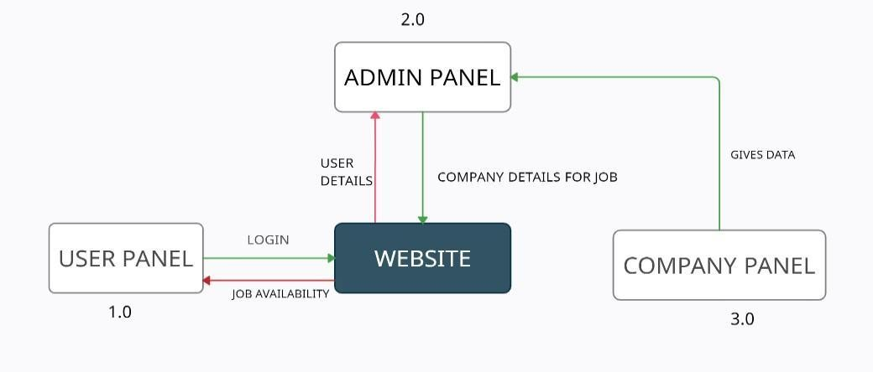

Figure 4.2.1: Zero level DFD diagram

### Level one DFD for 1.0:

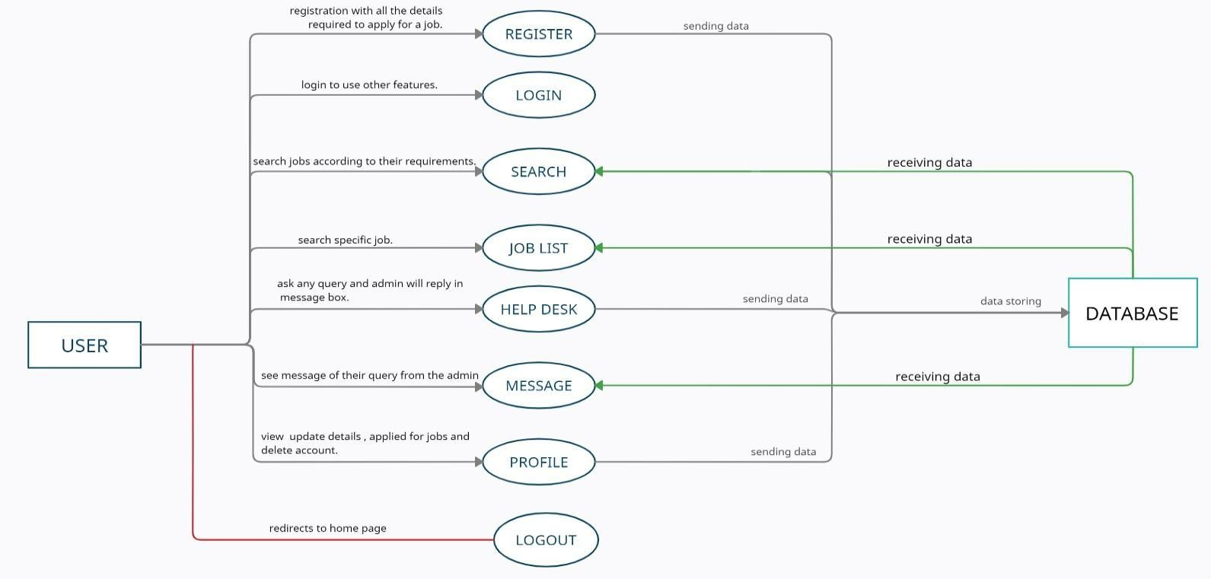

Figure 4.2.2: Level one DFD for 1.0 diagram

### Level one DFD for 2.0:

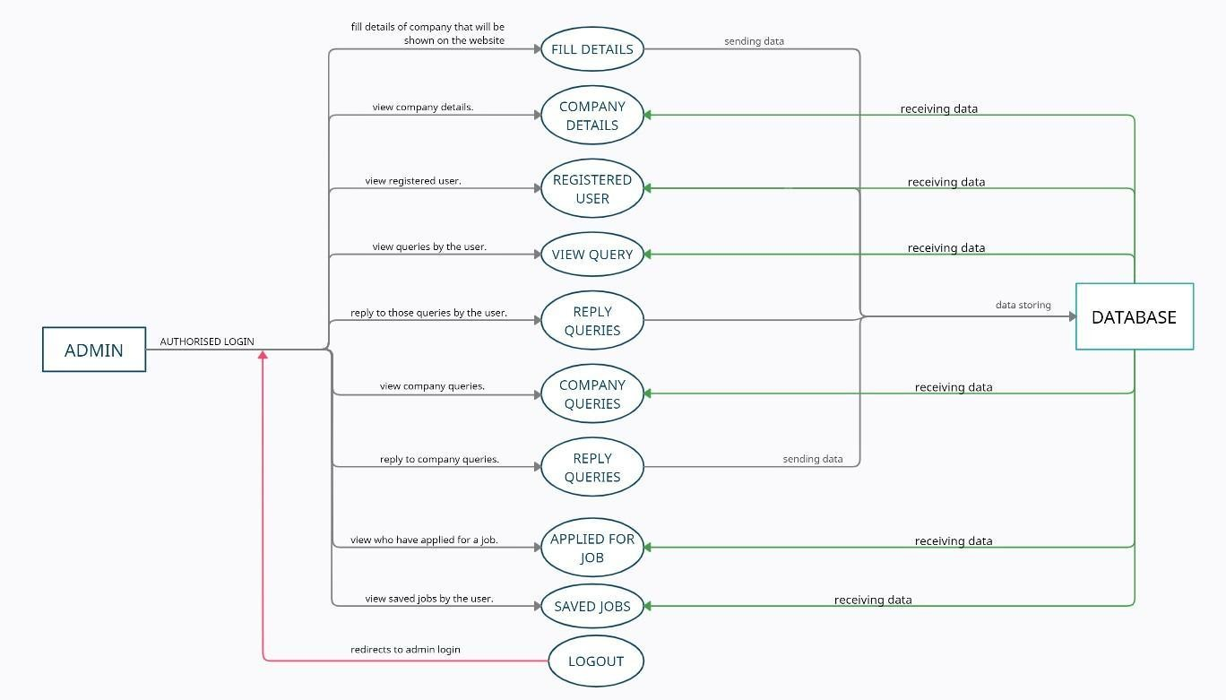

Figure 4.2.3: Level one DFD for 2.0 diagram

### Level one DFD for 3.0:

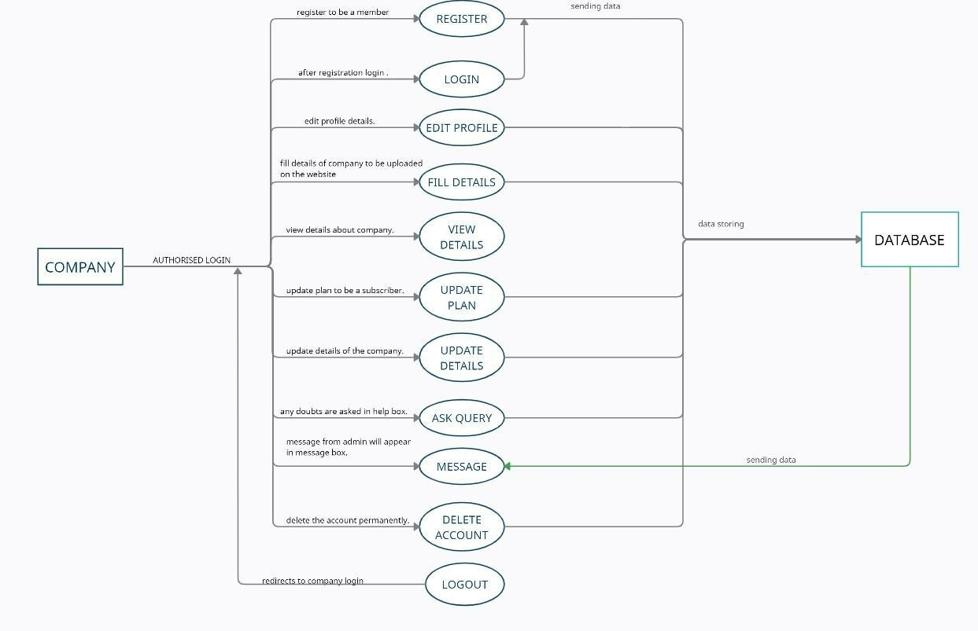

Figure 4.2.4: Level one DFD for 3.0 diagram

### 4.3 Entity Relationship Diagram (ER Diagram):

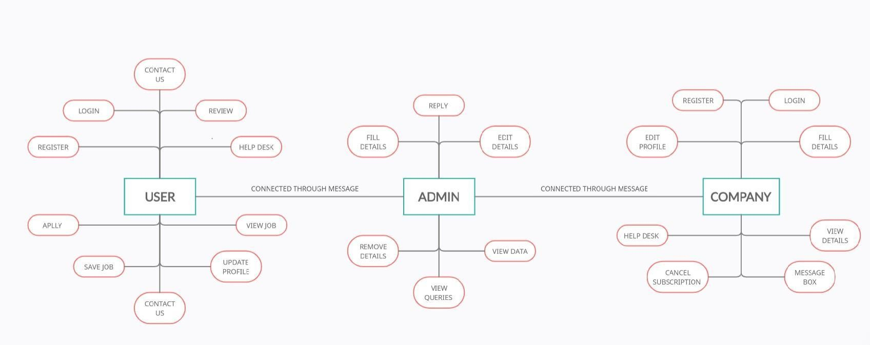

Figure 4.3: ER Diagram

### Database structures:

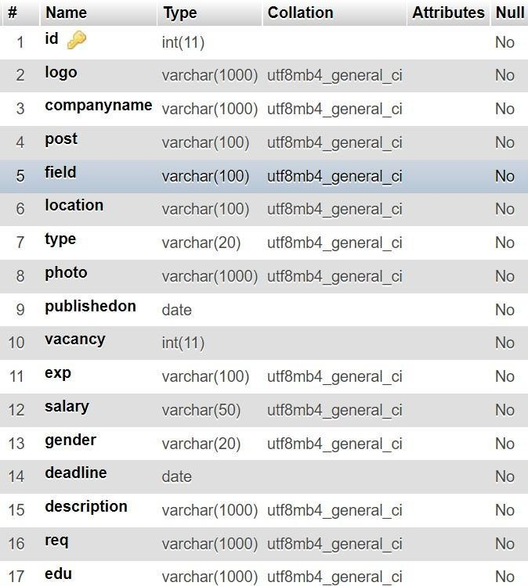

Table 4.4.1: Database structure of companies

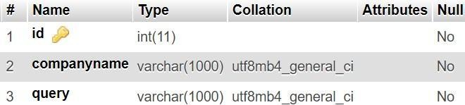

Table 4.4.2: Database structure of query of company

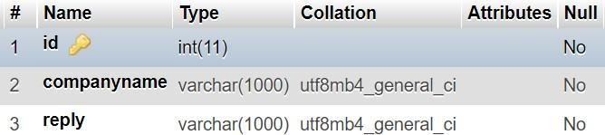

Table 4.4.3: Database structure of reply of company

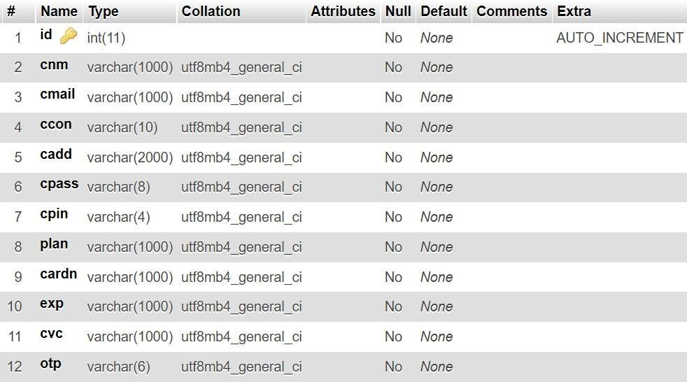

Table 4.4.4: Database structure of registration of companies

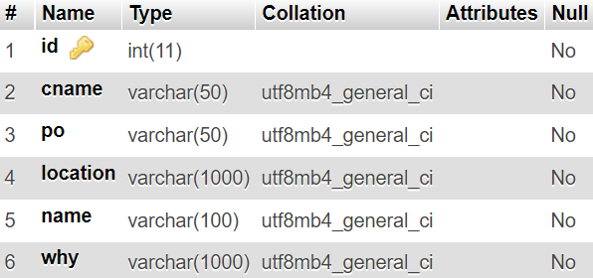

Table 4.4.5: Database structure of applied jobs by the user

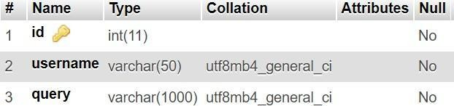

Table 4.4.6: Database structure of queries of user

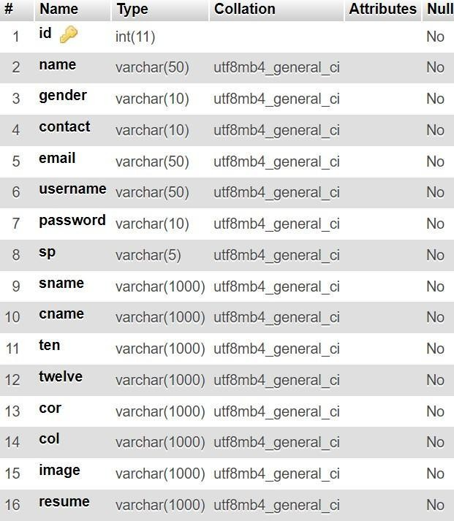

Table 4.4.7: Database structure of registration of user

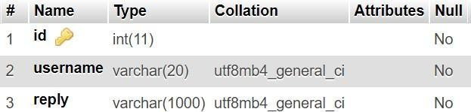

Table 4.4.8: Database structure of reply of queries of user

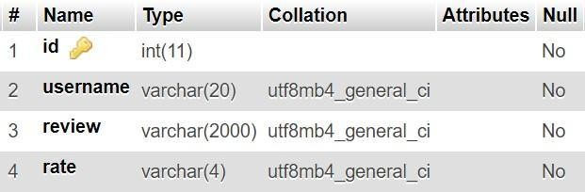

Table 4.4.9: Database structure of review by the user

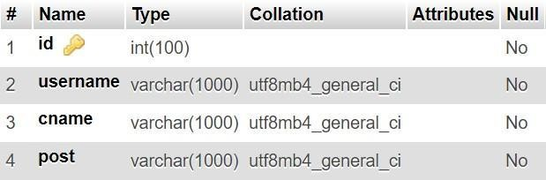

Table 4.4.10: Database structure of saved job

### Snap Shots of designing phase:

Image 4.5.1: website’s home page



Image 4.5.2: website’s home page

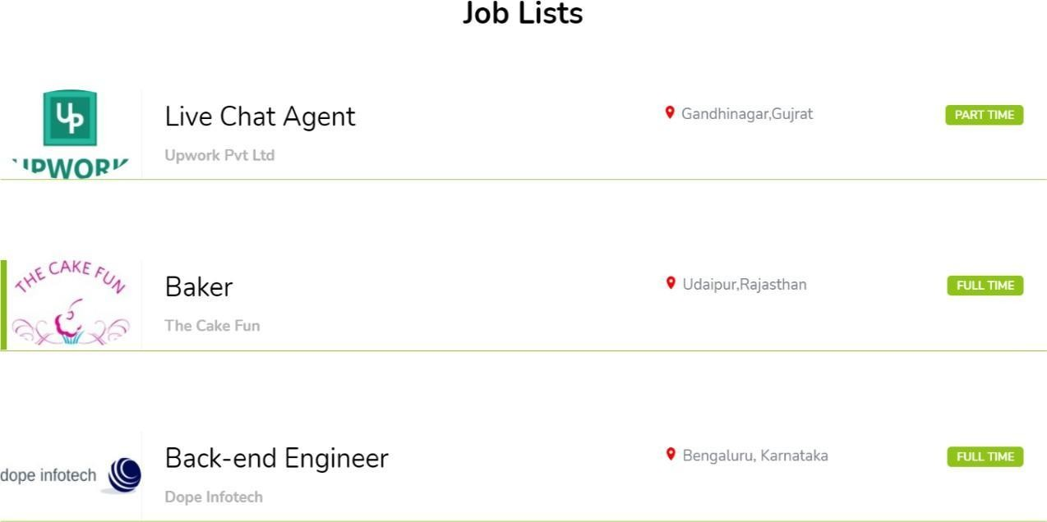

Image 4.5.3: website’s home page

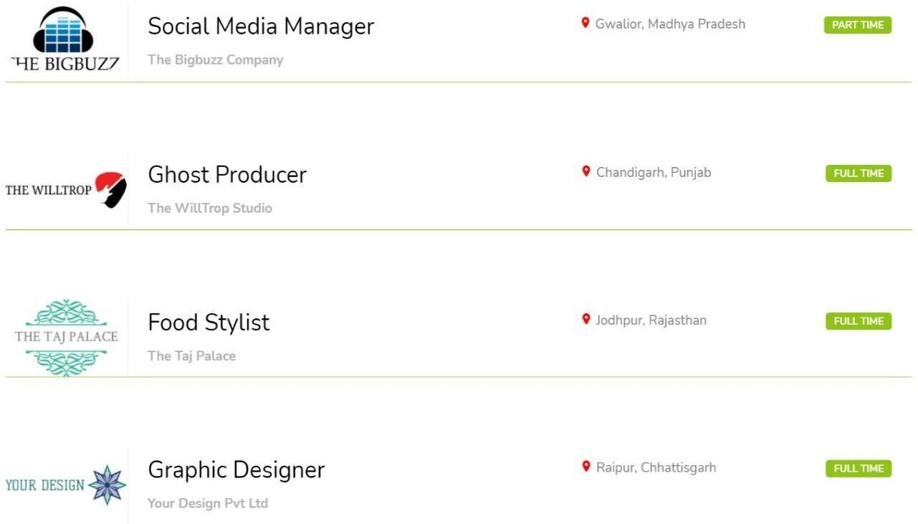

Image 4.5.4: website’s home page

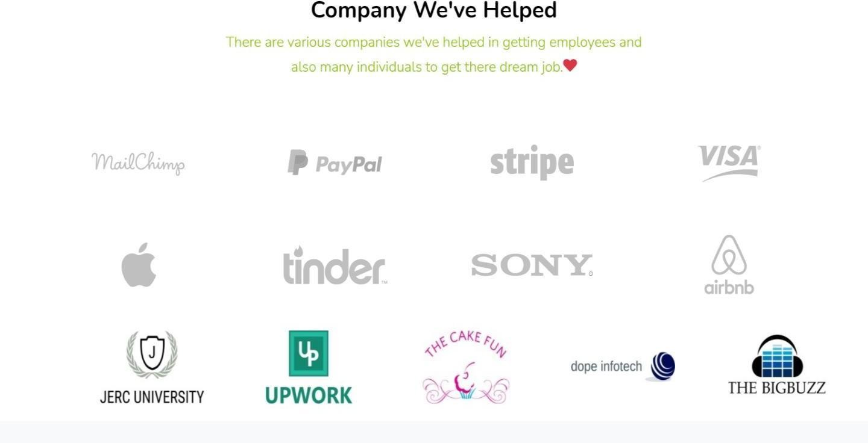

Image 4.5.5: website’s home page

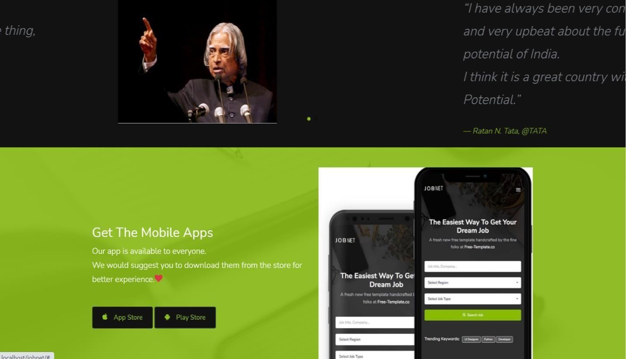

Image 4.5.6: website’s home page

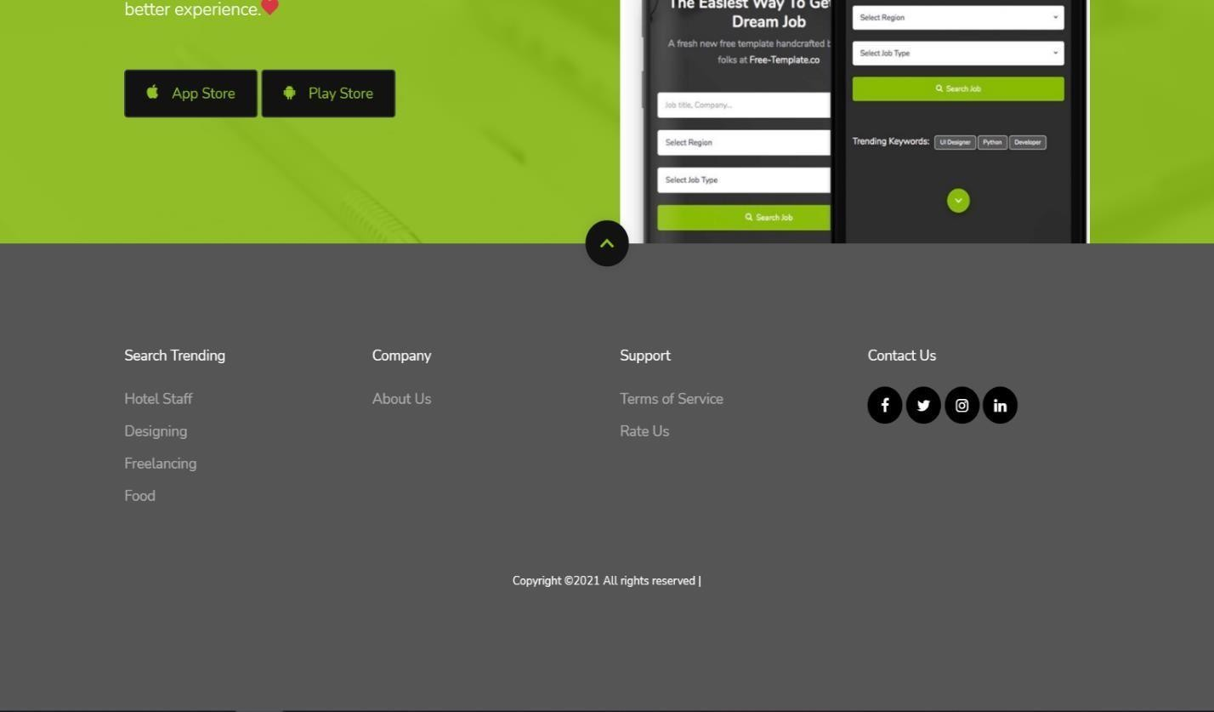

Image 4.5.7: website’s home page



Image 4.5.8: website’s job page



Image 4.5.9: website’s job page



Image 4.5.10: website’s job page



Image 4.5.11: website’s job page



Image 4.5.12: website’s job page

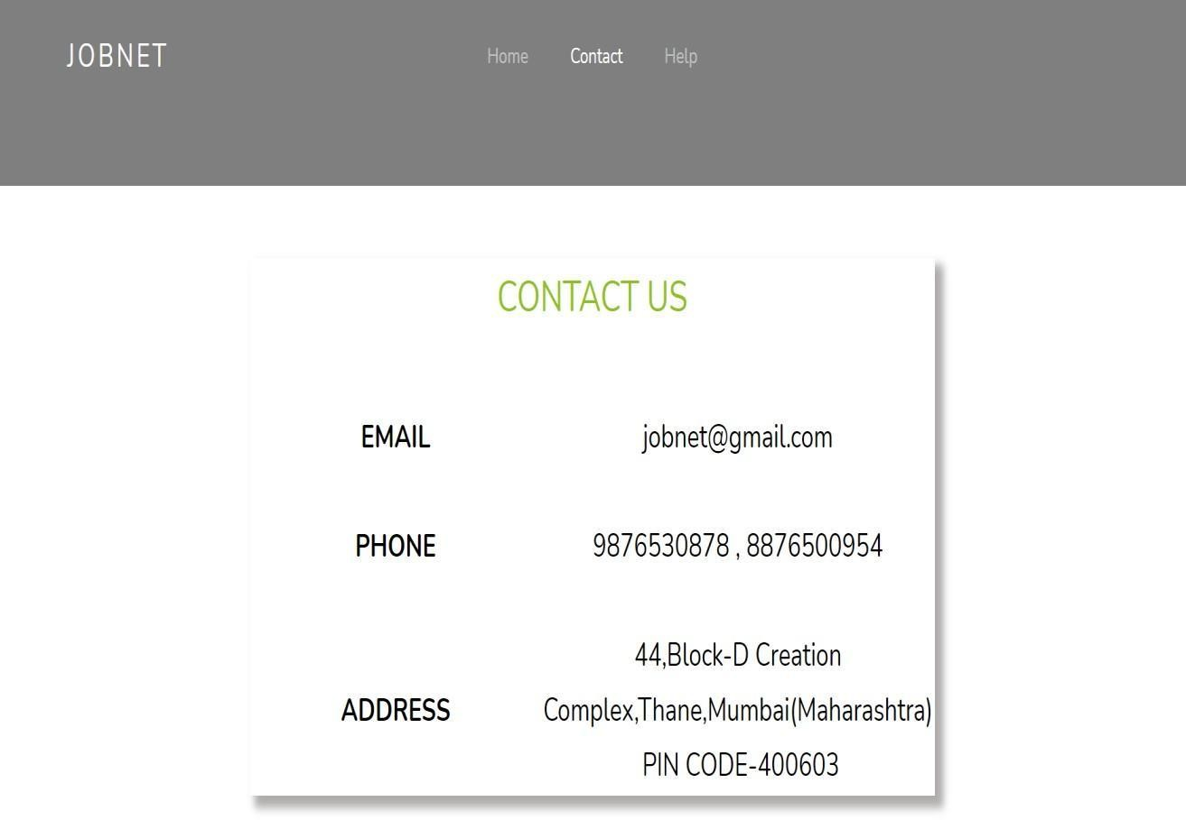

Image 4.5.13: website’s contact us page

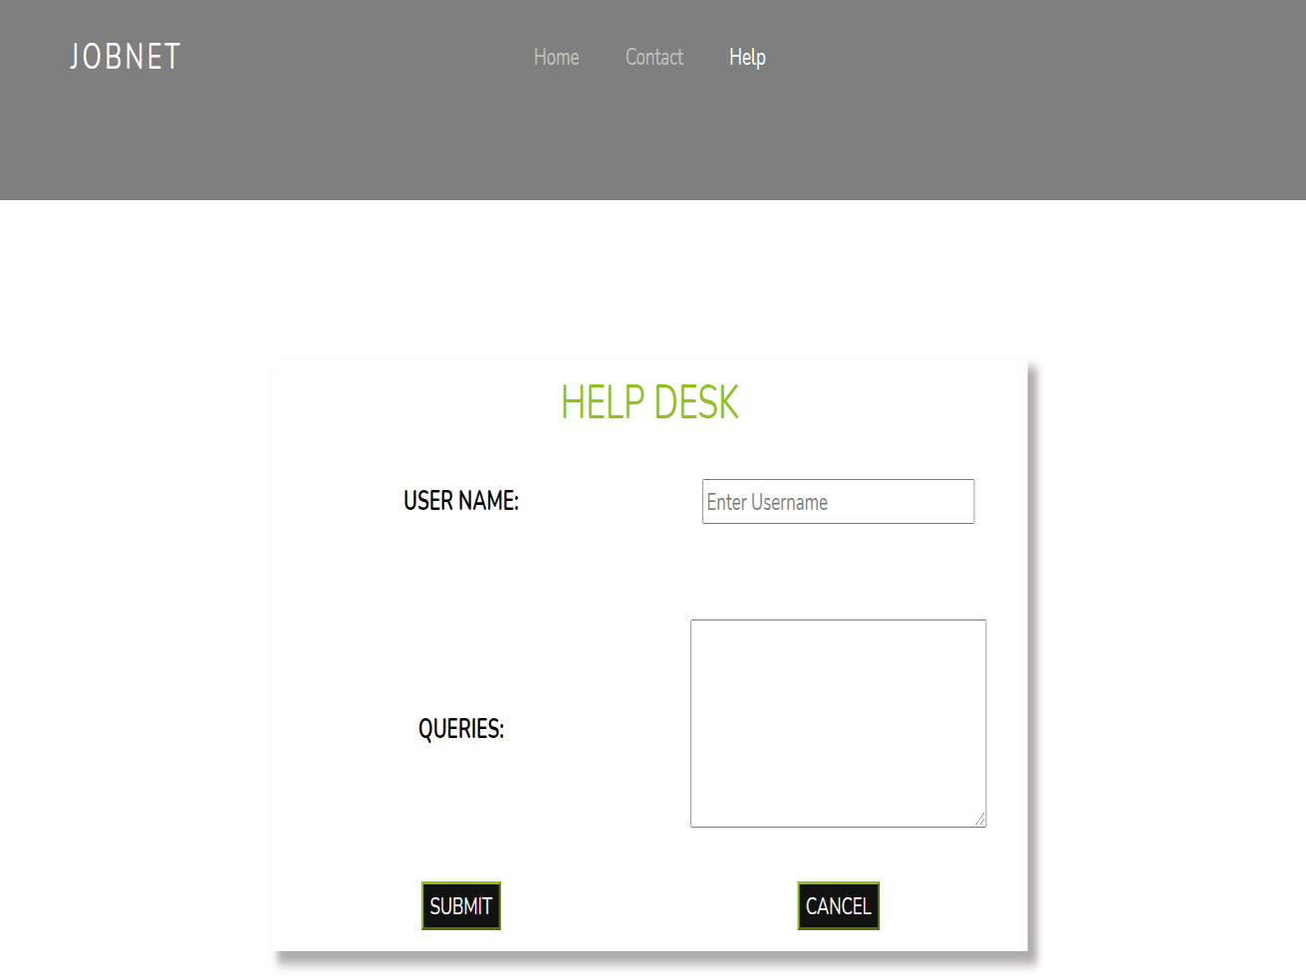

Image 4.5.14: website’s helpdesk page

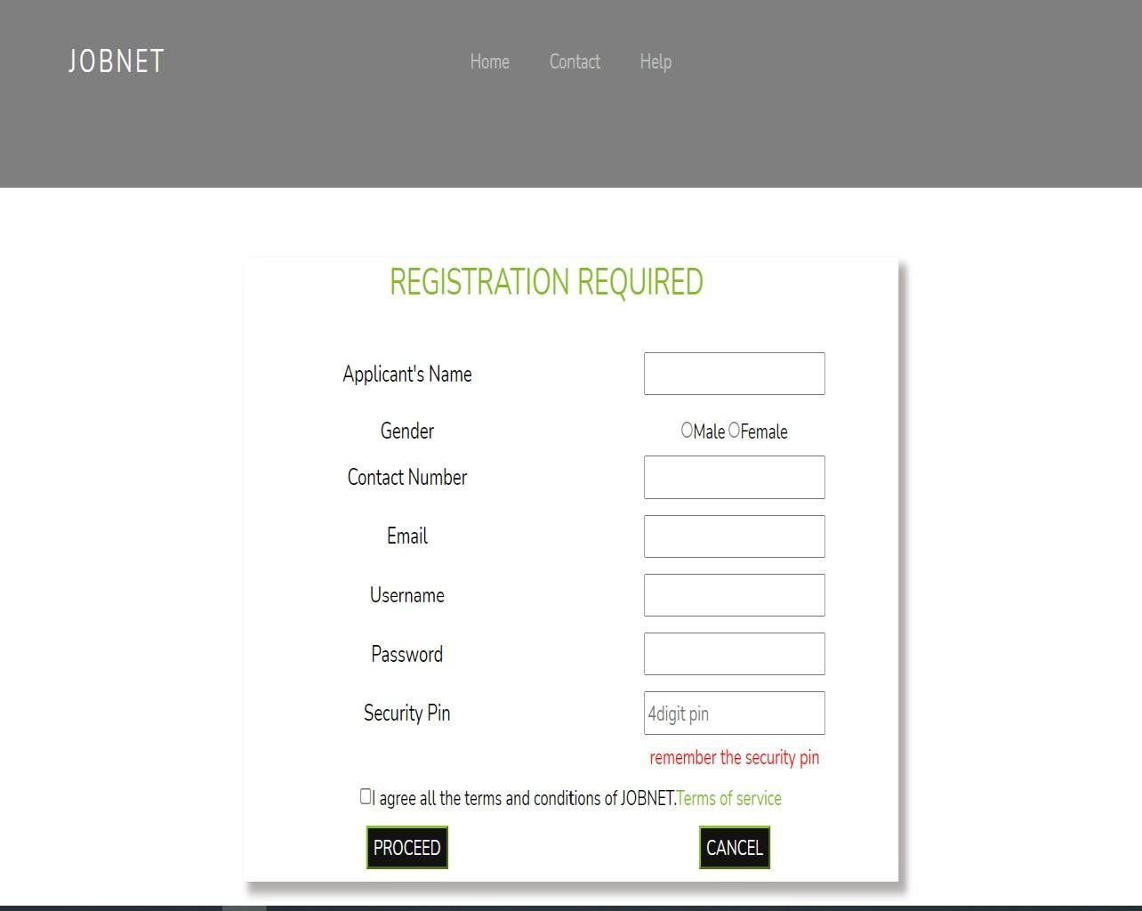

Image 4.5.15: website’s registration page

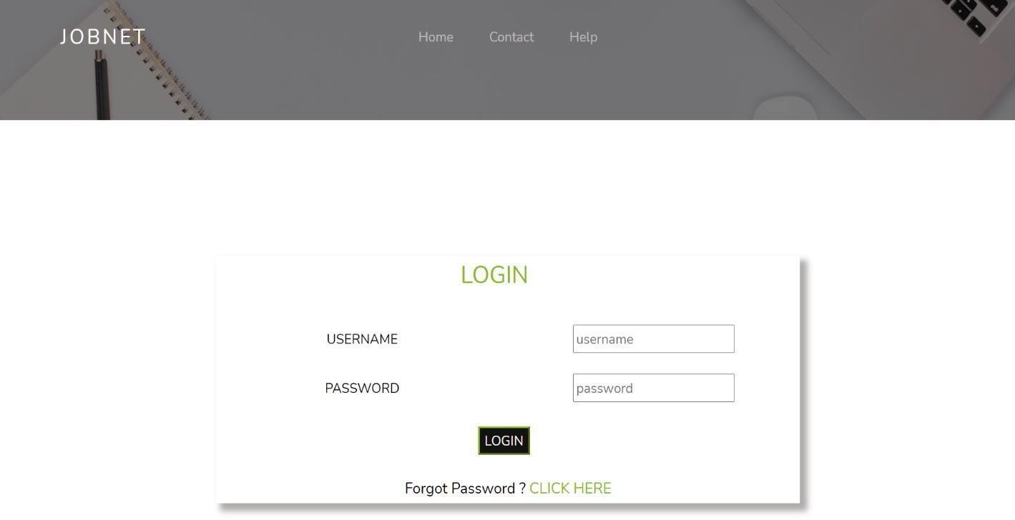

Image 4.5.16: website’s login page

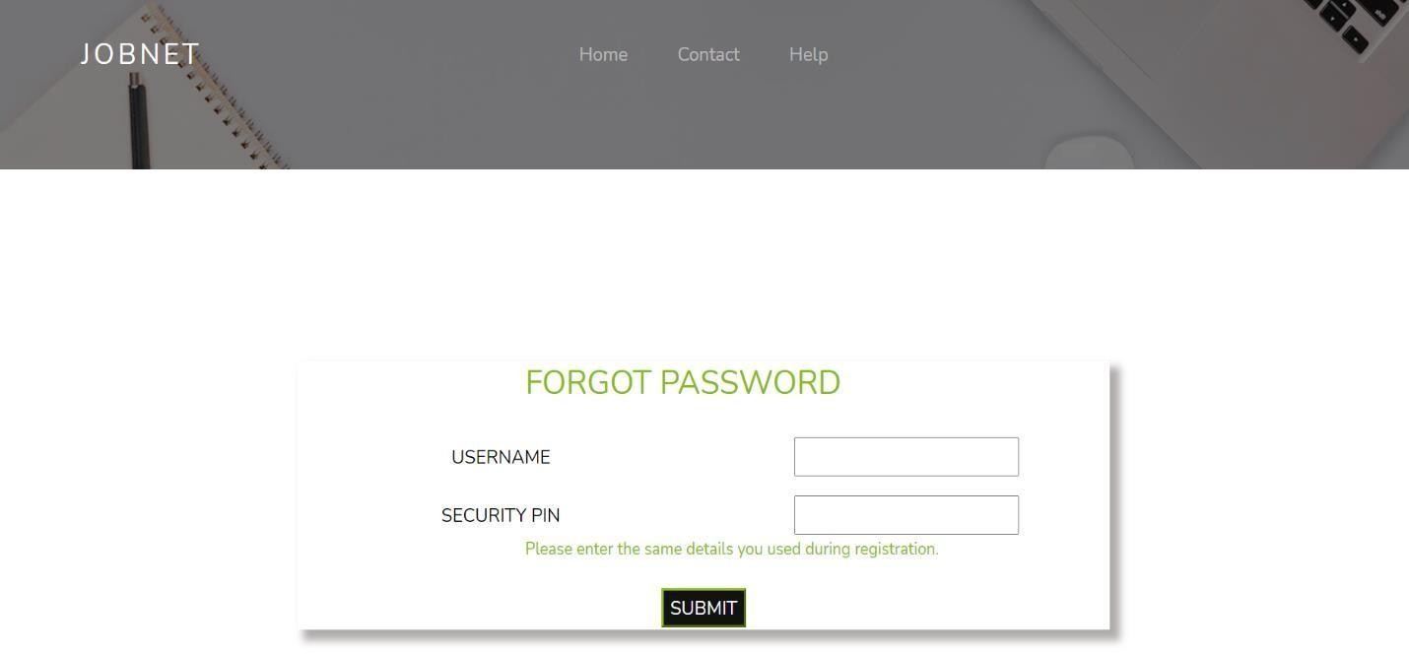

Image 4.5.17: website’s forgot password page

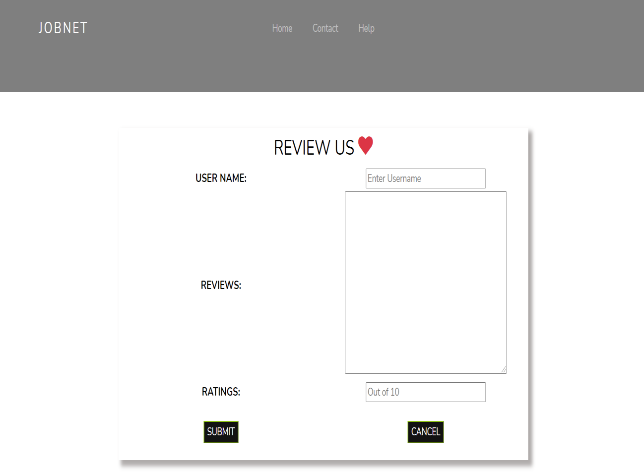

Image 4.5.18: website’s review page

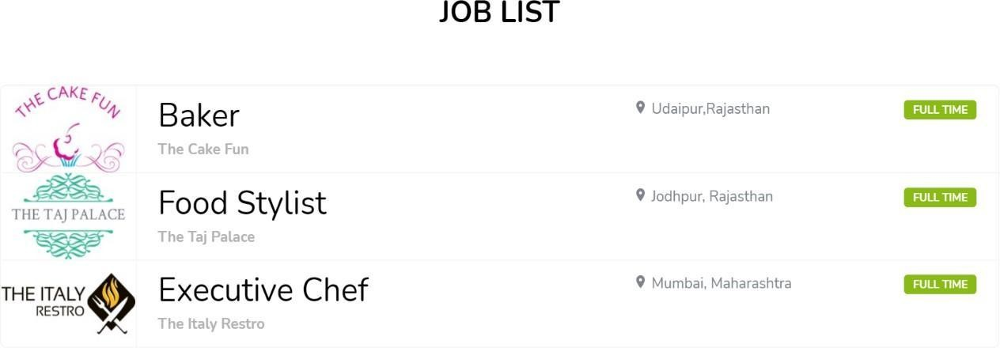

Image 4.5.19: website’s food list page

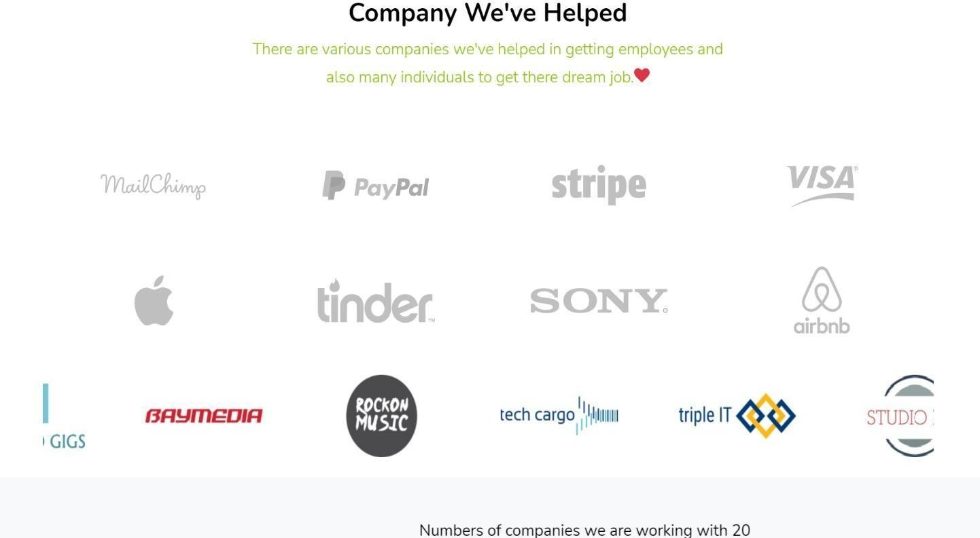

Image 4.5.20: website’s scrolling companies in home page



Image 4.5.21: website’s home page after login

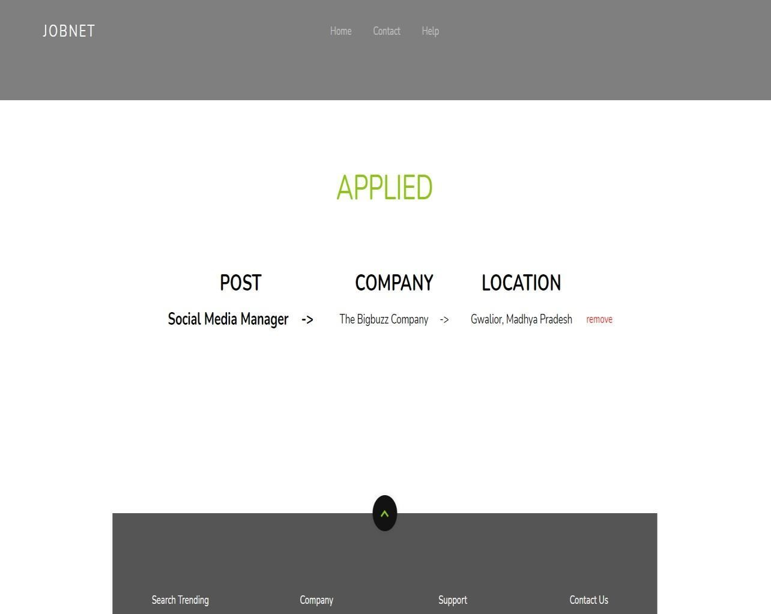

Image 4.5.25: website’s applied page

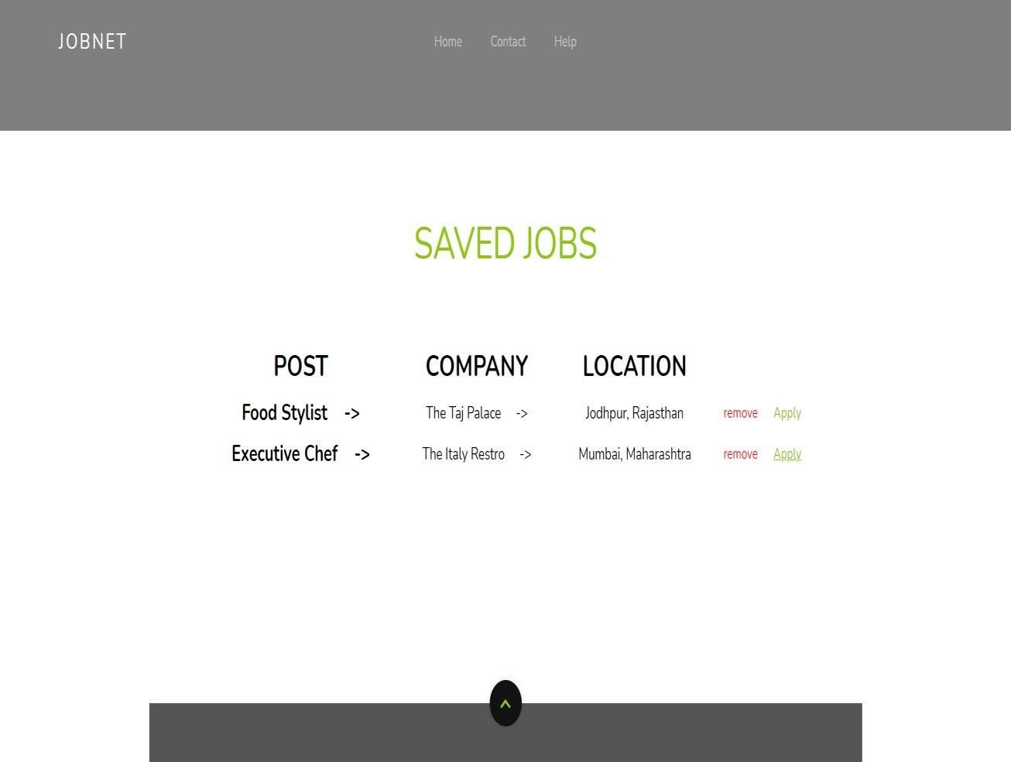

Image 4.5.26: website’s saved jobs page

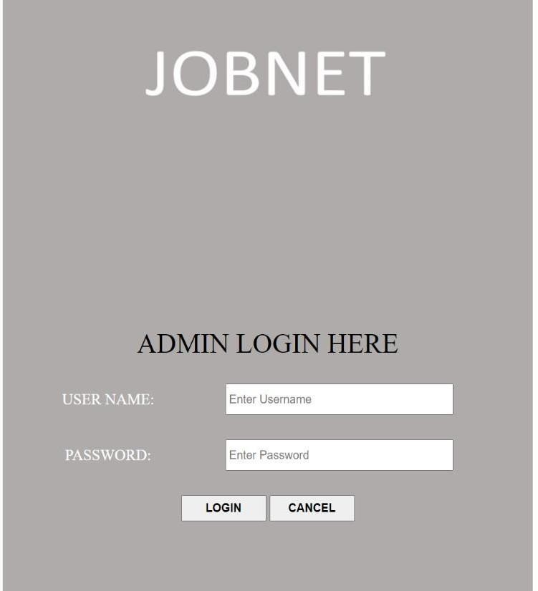

Image 4.5.27: admin’s login page



Image 4.5.28: admin page

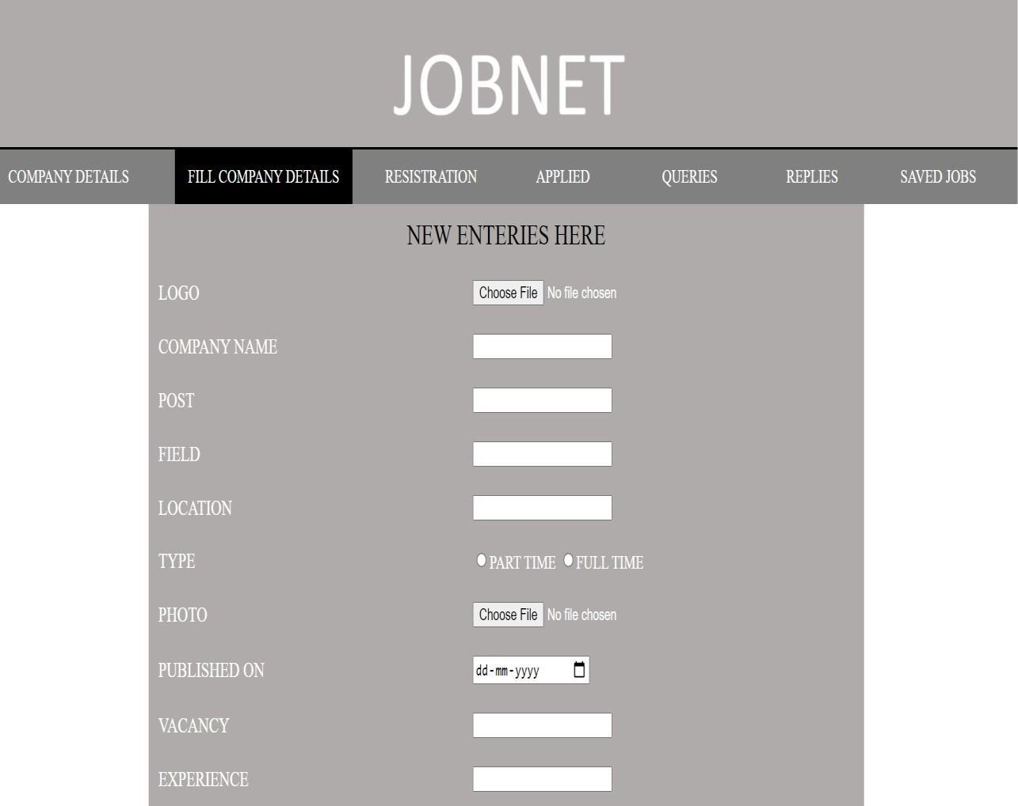

Image 4.5.29: admin’s fill details page

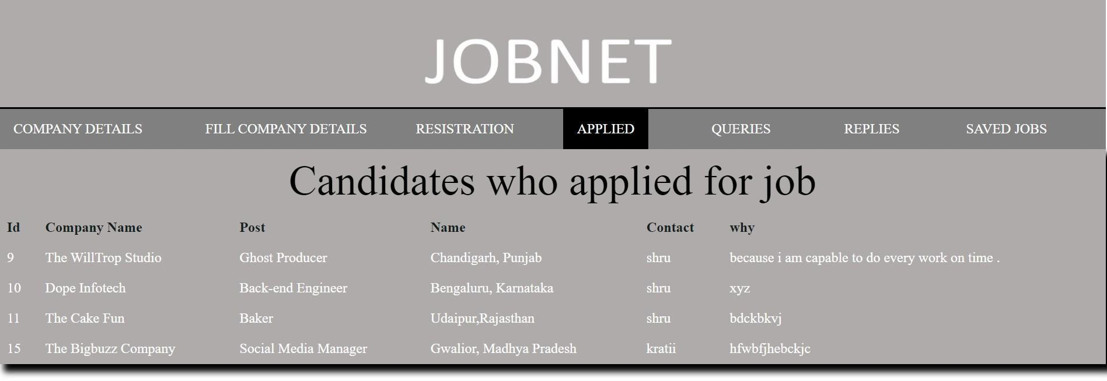

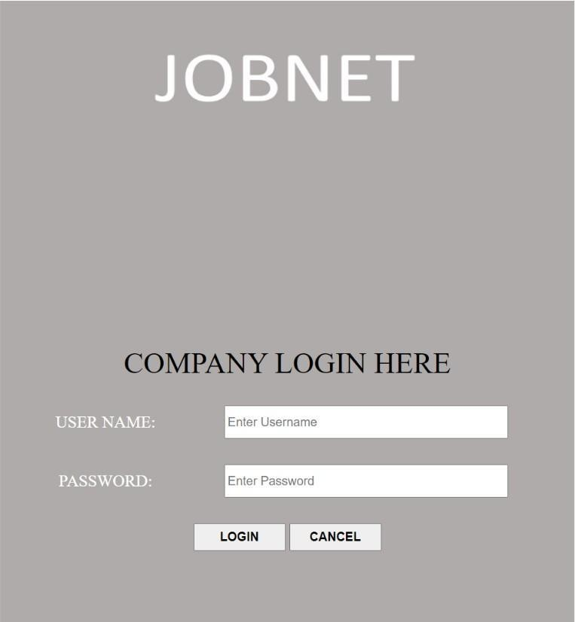

Image 4.5.35: company’s login page

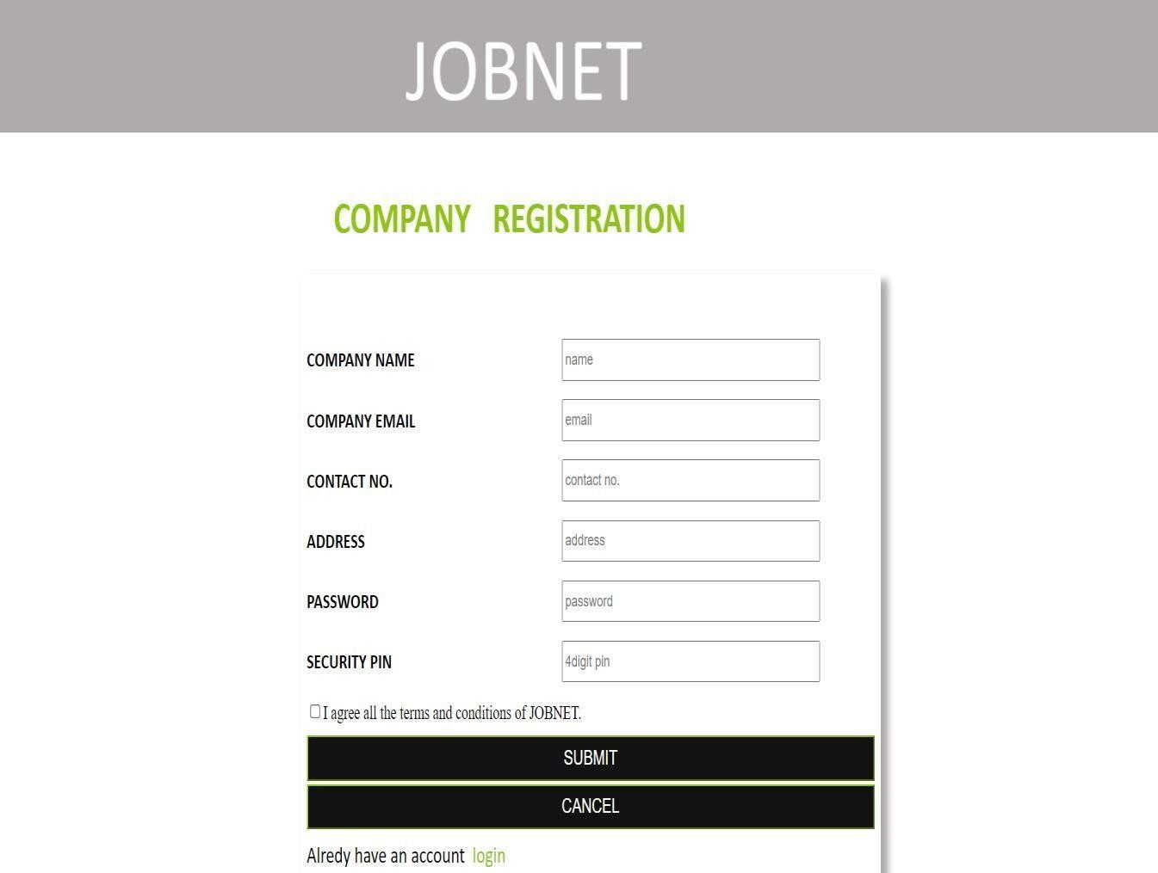

Image 4.5.36: company’s registration page1

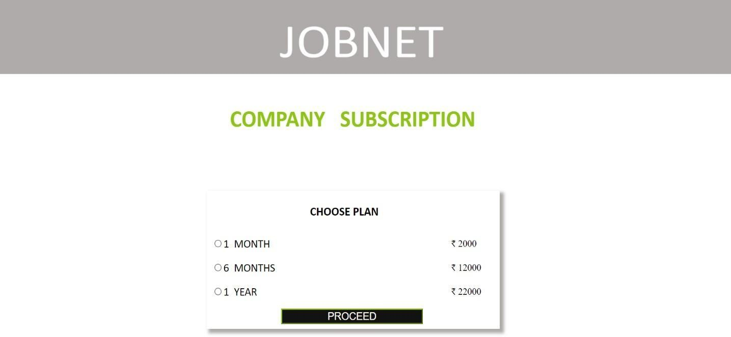

Image 4.5.37: company’s registration page2

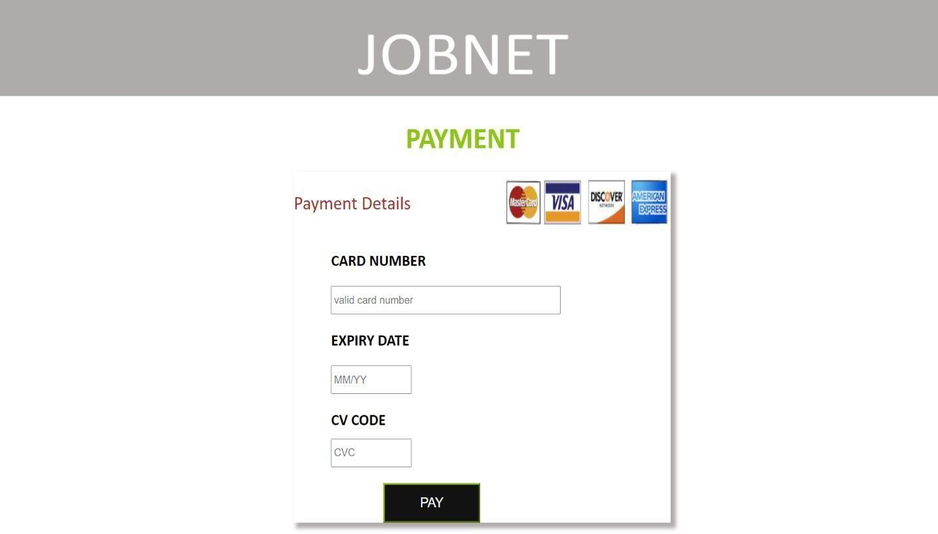

Image 4.5.38: company’s registration page3

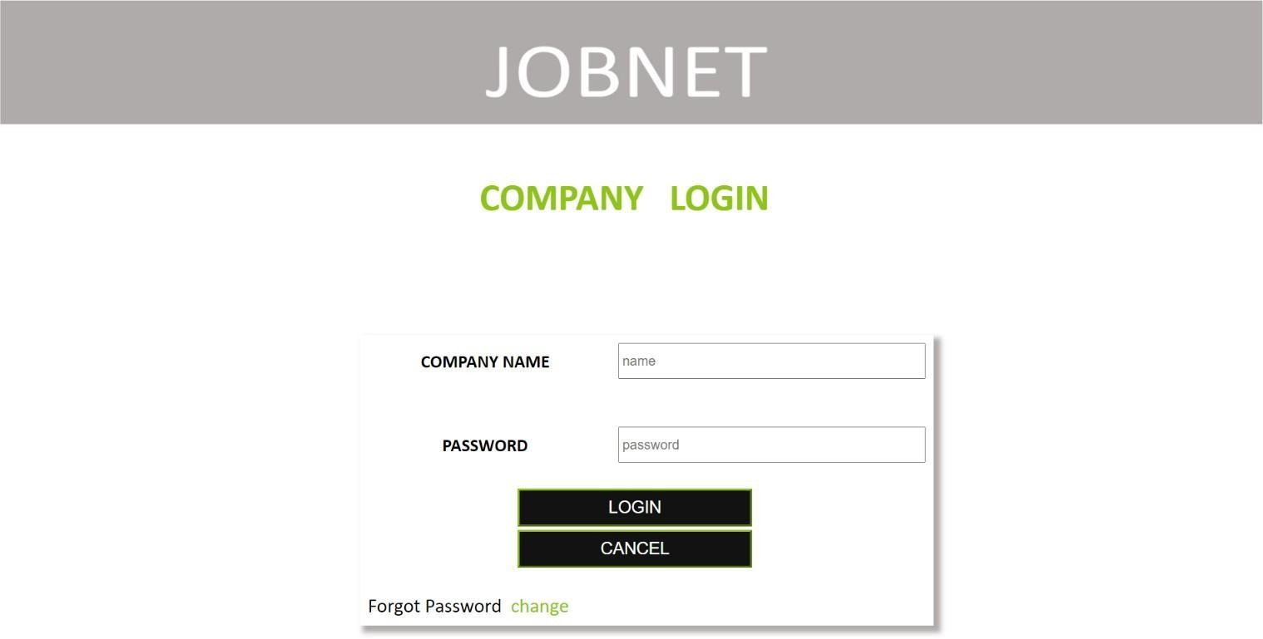

Image 4.5.39: company’s login page

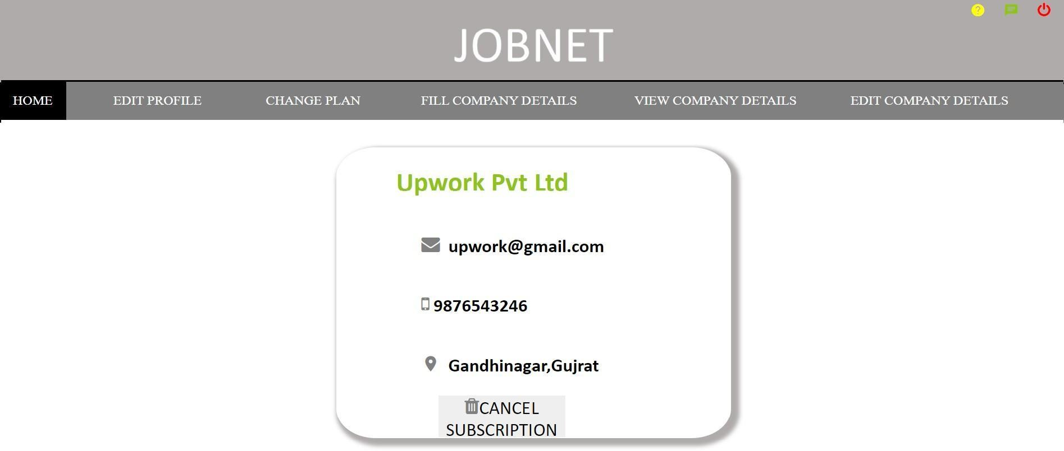

Image 4.5.40: company’s home page

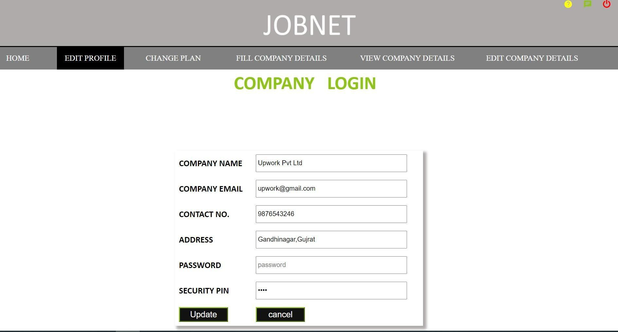

Image 4.5.41: company’s edit profile page

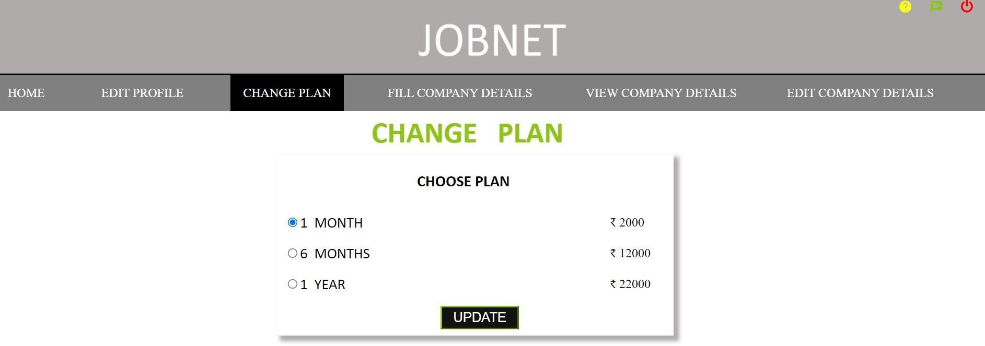

Image 4.5.42: company’s change plan page

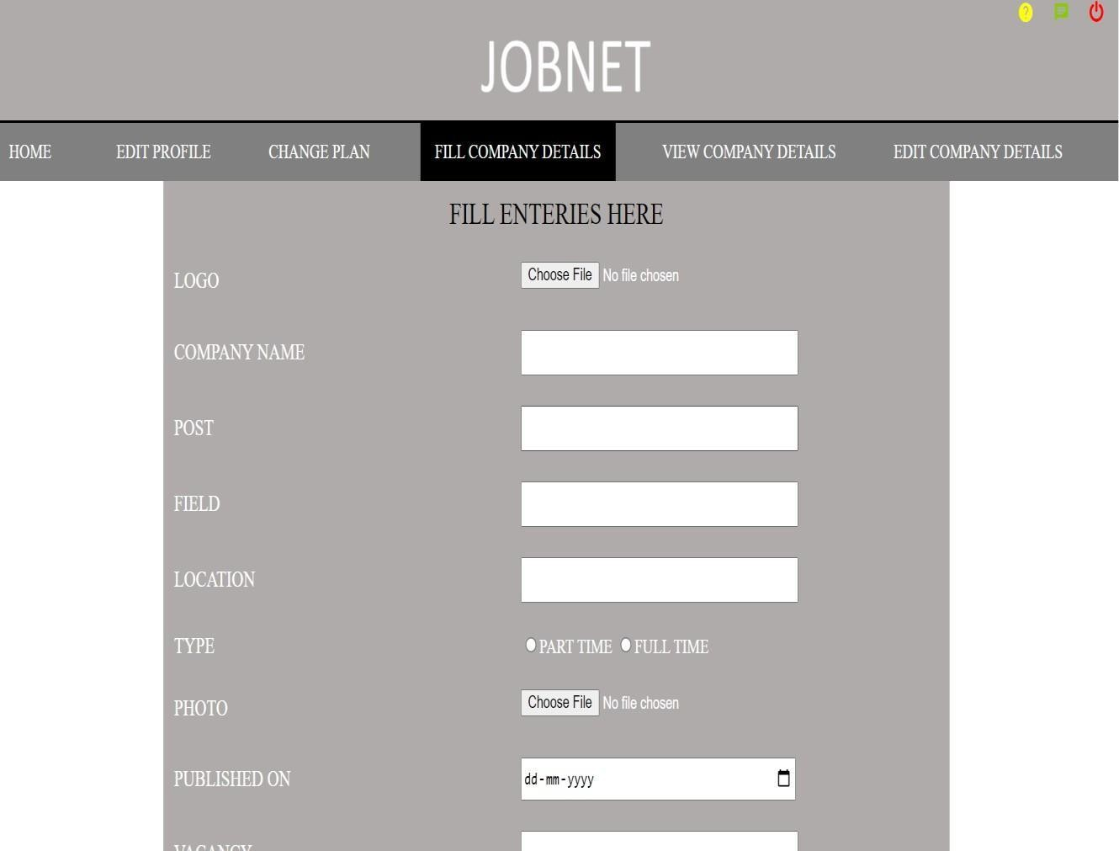

Image 4.5.43: company’s fill details page1

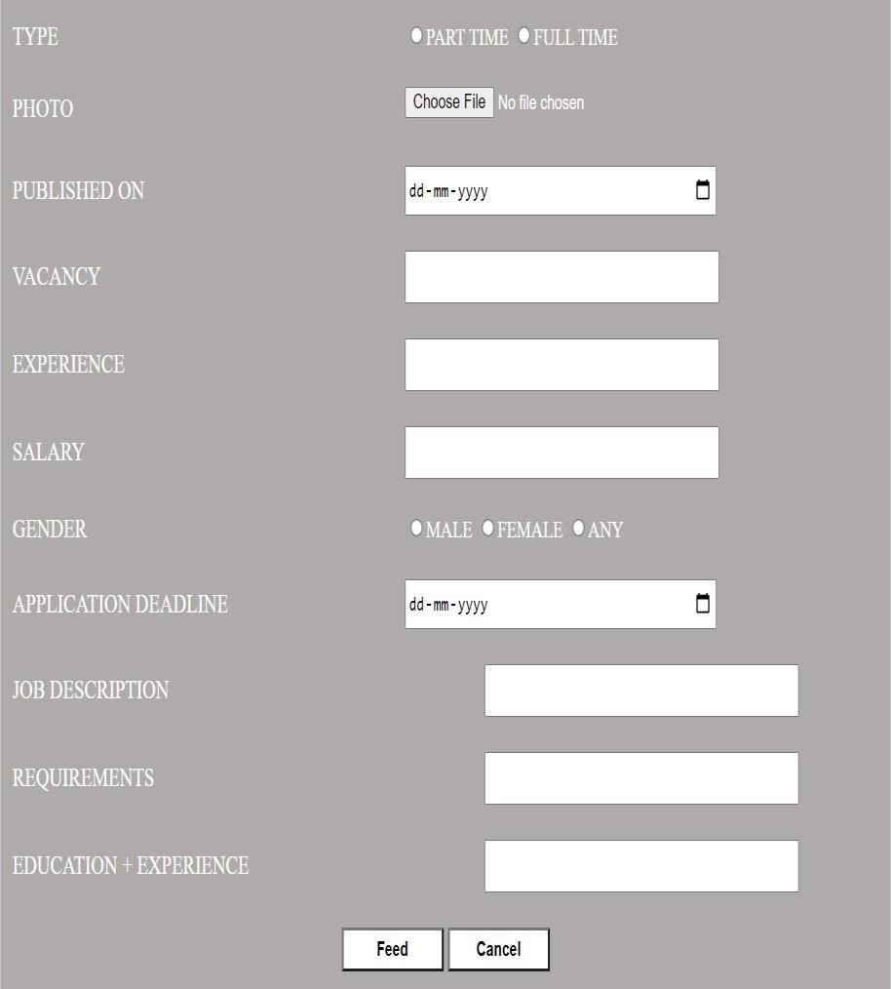

Image 4.5.44: company’s fill details page2

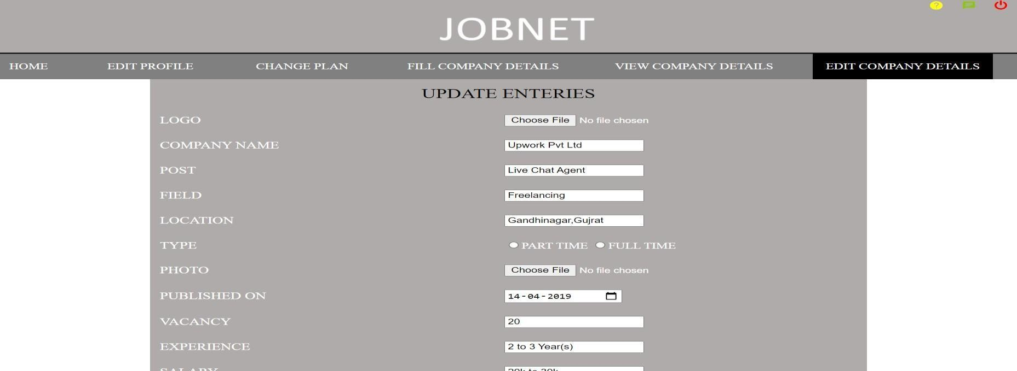

Image 4.5.45: company’s edit details page1

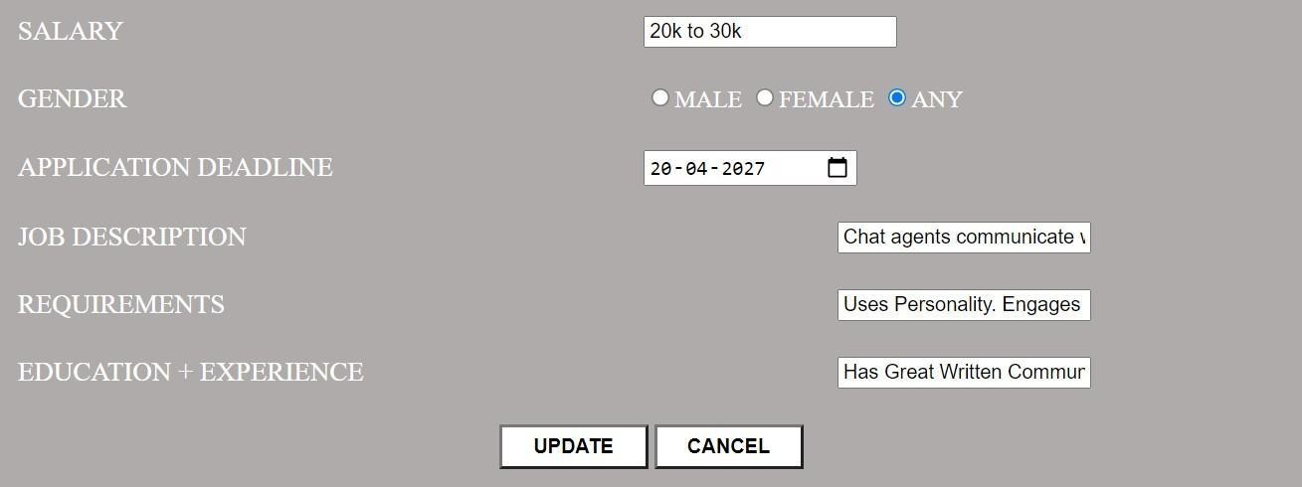

Image 4.5.46: company’s edit details page 2

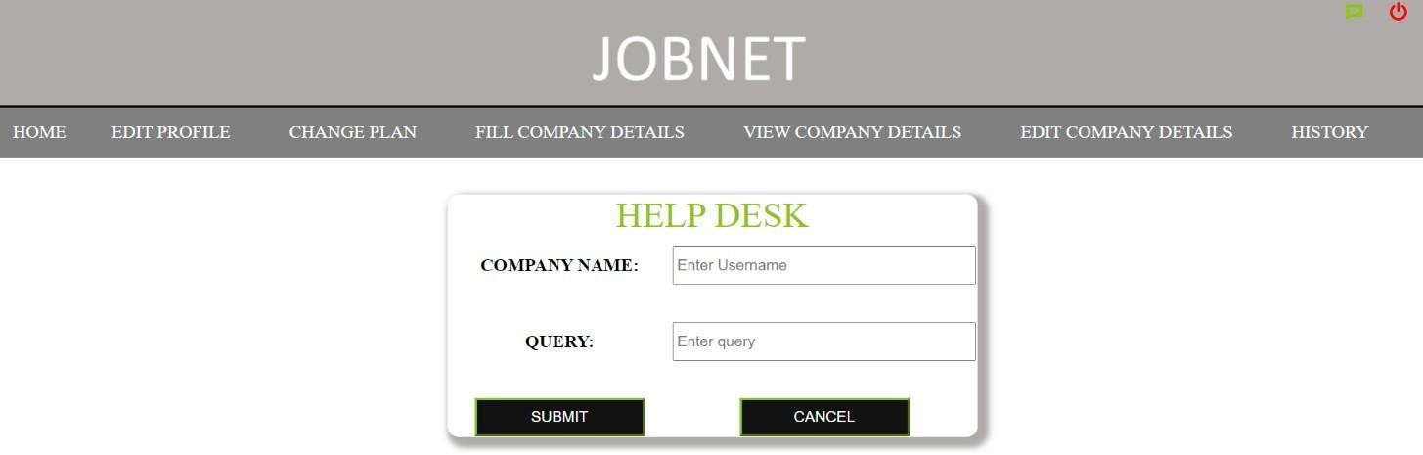

Image 4.5.47: company’s help desk page

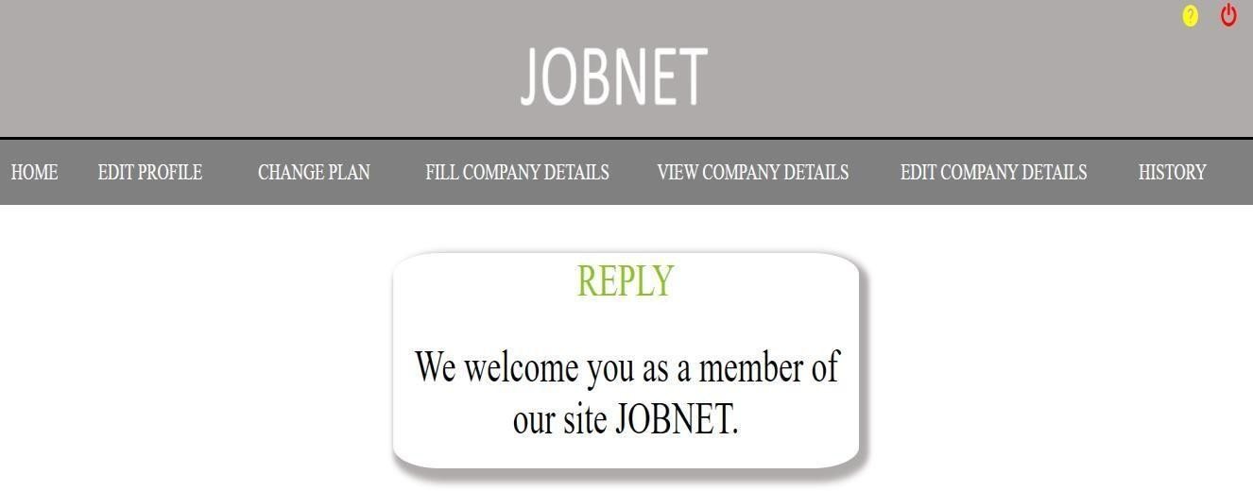

Image 4.5.48: company’s view message page

## CHAPTER 5 MECHANISMS USED

### Testing overview:

Software testing is any activity aimed at evaluating an attribute or capability of a program or system and determining that it meets its required results. Although crucial to software quality and widely deployed by programmers and testers, software testing still remains an art, due to limited understanding of the principles of software. In this project “**White Box Testing**” was performed, which is a software testing method in which the internal structure/ design/ implementation of the item being tested is known to the tester.

#### System testing:

Testing is an important part of software development. It is the process of finding errors and missing operations and also a complex verification to determine whether the objectives are met and the user requirements are satisfied. Following testing was carried out:

#### Unit Testing :

The first includes unit testing, where each module is tested to provide its correctness, validity and also determine any missing operations and to verify whether the objectives have been met. Errors are noted down and corrected immediately. Unit testing is the important and major part of the project, so errors are rectified easily in a particular module and program clarity is increased. Our project is divided into several modules and is developed individually which helped in conducting unit testing.

#### Integration Testing:

The second step includes integration testing. It needs not to be the case, the software whose modulus run individually and showing perfect results will also show perfect results when running as a whole. The individual modules are clipped under this major module and tested again verified the results. This is due to poor interfacing which may result in data being lost across an interface. A module can have an inadvertent, adverse effect on any other or on the global data structures, causing serious problems**.**

#### Validation:

The final step involves validation and testing which determines whether the software functions as the user expected.

#### Client-Side Validation:

Various client-side validations are used to ensure in the client side that only valid data is entered. A client-side validation saves time and load to handle invalid data. Some checks imposed are:

The script is used to ensure those required fields are filled with suitable data only. Maximum lengths of the fields of the forms are appropriately defined.

Forms cannot be submitted without filling up the mandatory data so that manual mistakes of submitting empty fields that are mandatory can be sorted out at the client side to save the server time load

Tab-indexes are set according to the need and taking into account the ease of user, while working with the system.

#### Server-Side Validation:

Some checks cannot be applied on the client-side. Server-side checks are necessary to save the system from failing and intimating the user that some invalid operations have been performed or the performed operation is restricted. Some of the server checks imposed are:-

Server side constraints have been imposed to check for the validity of primary key and foreign key. A primary key value cannot be duplicated.

The user is intimated through messages about the successful operations or exceptions occurring at the server-side.

Various Access Control Mechanisms have been built so that one user may not agitate upon another. Access permissions to various types of users are controlled according to the organizational structure. Only permitted users can log on the system and can have access according to their category. User-name, passwords, and permissions are controlled the server side.

## CHAPTER 6 IMPLEMENTATIO N

### Implementation mechanisms used:

Implementation is the stage where the theoretical design is turned into a working system. The most crucial stage is achieving a new successful system and in giving confidence in the new system for the users that it works efficiently and effectively.

The implementation phase comprises of several activities. In the first phase, the required hardware and software acquisition was carried out. Updating the old website involved careful planning, investigation of the current system and its constraints on implementation, the design of methods to achieve the changeover and evaluation of change over methods apart from planning.

After which the initial draft of the homepage and secondary page UI was generated. After knowing the design of our project I looked up for the technologies that could help me in creating a replica of the design.

Once I decided the technologies to be used then I encountered the problem of data flow as the existing system had a lot of operations going on. To solve these problems I created a data flow diagram up to level one and I also made a sitemap so as to keep a track of the pages we were going to work on.

Once all the things were planned out I started their implementation and in the process, I did the following things:

* + 1. Search function:

First, the user will register and then login in the website then the search box will be shown and according to the requirements user can search for jobs.

* + 1. Saving jobs:

Once, logged in user can save any specific job and later can apply for it.

* + 1. Company slider:

The user can see list of companies having vacancy through a slider .

* + 1. Admin panel (submitting notifications):

The admin is provided a combo box for various notification types. According to the user’s selection, the table in the database is selected and related data is submitted.

* + 1. Admin panel (submitting media):

The admin is provided with a text field for entering the event name. Each time a new event is entered a directory is created to hold the data of that event. This gives a better hierarchical structure for holding content.

* + 1. Company Panel:

The company panel is provided so that company can register for giving vacancies in my website. Updating profile, filling details ,change in plan these features are in company panel.

* + 1. In the last phase of my project, I did testing of my project and found some minor setbacks out of which I was able to resolve a few of them.I am able to achieve most of my design.

## CHAPTER 7 LIMITATIO N

### Limitations:

After thorough testing, some drawbacks were found that were not working according to the specifications. They are:

* + - * 1. For admin and company there should be a function which lets them to see whether the company which has provided the vacancy is activated or deactivated.
        2. The homepage can be designed in a way more organized manner so as to load faster for slower internet connections (due to heavy use of external libraries and fonts).
        3. The subscription of company could be made in well manner so that it would be easier for company to choose a plan.

## CHAPTER 8 CONCLUSION

### 8.1. Conclusion:

The main purpose of the project is to make a customer satisfactory system by providing all the basic features as well as some important features for special-aid people. Since the project is an update of the old website changing the UI and UX overhaul of the existing website helped in providing a fresh and different perspective for the end user.

We all are aware that an institution’s website speaks volumes about its work. It is usually going to be the first thing a parent or a student is going to look at. Therefore, it is imperative that it is user-friendly, optimized and well designed.

The project was developed with a modular approach. All the modules in the system have been tested valid data and invalid data and everything works successfully. Thus the system has fulfilled all the objectives identified and is able to replace the existing system. The constraints are met and overcome successfully. The system is designed as it was decided in the designing phase.

# CHAPTER 9 FUTURE SCOPE

### Future scope:

* + 1. If websites app is made for mobile then it would be easier for user to use it. 2.Website should be made responsive for better use .

3.Jobs for fresher and internships should also be added as a feature in this website. 4.Paid membership for the users.